SIMATS ENGINEERING
Department of Computer Science and Engineering
ASSESSMENT TOOL 1 – ANALYTICAL PROBLEM SOLVING
Course Code: | CSA12 | Course Title: | Computer Architecture
CO Assessed: | CO2 – Precision (BL3) | Assessment: | Analytical Problem Solving
Weightage: | 45% | Total Marks: | 100
CO2 Statement: | Apply integer and floating-point arithmetic algorithms including Booth's multiplication, restoring/non restoring division, and IEEE 754 standard operations to solve fixed-point and floating-point computational problems.
Student Name: | REKANTH.K | Reg. No.: | 192411213
Section / Batch: | 2023 | Date: | 03-08-2024

Instructions to Students
• Identify the appropriate arithmetic algorithm or number representation required for the given computational problem.
• Analyse the step-by-step execution of integer and floating-point arithmetic operations using the selected algorithm. • Apply Booth's multiplication, restoring/non-restoring division, and IEEE 754 standards to obtain accurate results. • Compute binary multiplication, division, normalization, and floating-point arithmetic using appropriate algorithms. • Interpret the computed results by evaluating their accuracy, precision, and suitability for the given application.

QUESTIONS
1. A processor performs arithmetic operations on signed 8-bit integers using 2’s complement representation. Consider two numbers: +45 and −23. Analyse in detail how the system performs both addition and subtraction, including binary conversion, alignment of sign bits, and intermediate steps. Determine whether overflow occurs, and explain how the processor detects overflow and interprets the final result.
2. A high-performance computing system replaces a ripple carry adder with a 4-bit carry look-ahead adder (CLA) to reduce computation delay. Given two binary inputs, analyze how generate and propagate signals are formed and how carries are computed in advance. Compare the time delay of CLA with ripple carry addition and justify, with reasoning, why CLA improves speed in modern processors.
3. In a signed multiplication operation, a processor uses Booth’s algorithm to multiply two numbers, −6 and +5. Analyze the algorithm step-by-step, including the role of the accumulator, multiplier, and Booth bit, along with arithmetic shifts. Explain how the algorithm efficiently handles signed numbers and reduces the number of addition/subtraction operations compared to traditional multiplication.
4. A processor is required to perform division of two binary numbers (e.g., 13 ÷ 3) using both restoring and non-restoring division algorithms. Analyze both methods step-by-step, showing intermediate remainders and quotient formation. Compare the two approaches in terms of number of steps, complexity, and efficiency, and explain why non-restoring division is often preferred in modern systems.
5. A scientific application requires precise handling of real numbers using the IEEE 754 standard for floating point representation. Given a decimal number (e.g., −13.25), analyse how it is represented in both single precision and double precision formats, including sign, exponent, and mantissa fields. Further, explain how floating-point addition is performed between two such numbers, highlighting issues like normalization, rounding, and precision loss.
Code of Conduct
I K REKANTH-192311213 certify that this submission is my original work and that I have adhered to the guidelines specified for this assessment. I understand that any violation of academic integrity rules will result in disciplinary action.
Signature of the Student:K REKANTH

RUBRICS FOR CALCULATION
Criteria | Weightage | Level 4 – Exemplary (5 Marks) | Level 3 – Proficient (4 Marks) | Level 2 – Developing (2–3 Marks) | Level 1 – Beginning (0–1 Mark)
Problem  Understanding | 20% | Clearly interprets problem, identifies all parameters and requirements  accurately | Understands  problem with  minor gaps | Partial  understanding;  misses key  elements | Misinterprets or  unable to understand problem
Method  Selection | 20% | Selects most  appropriate  method/formula  with strong  justification | Selects correct  method with  minor errors | Inappropriate or  partially correct  method | Unable to select  method
Solution  Process | 25% | Logical, systematic steps with correct approach  throughout | Mostly correct  steps with minor mistakes | Disorganized steps; multiple errors | No clear process
Accuracy of  Calculation | 20% | All calculations  accurate; correct final answer | Minor calculation errors | Frequent errors;  incorrect final  answer | No valid calculations
Interpretation of Results | 15% | Clearly interprets results with units and engineering  relevance | Basic  interpretation with minor omissions | Limited or unclear interpretation | No interpretation

Marks Evaluation:
Q.  No | Problem  Understanding  (20) |  | Method  Selection (20) | Solution  Process (25) | Accuracy of  Calculation  (20) | Interpretation of Results (15) | Total  (out of 100)
1 | / 4 |  | / 4 | / 4 | / 4 | / 4
2 | / 4 |  | / 4 | / 4 | / 4 | / 4
3 | / 4 |  | / 4 | / 4 | / 4 | / 4
4 | / 4 |  | / 4 | / 4 | / 4 | / 4
5 | / 4 |  | / 4 | / 4 | / 4 | / 4
 | / 20 |  | / 20 | / 25 | / 20 | / 15 | / 100

Course Coordinator Faculty Incharge

Q1. Signed 8-bit Addition and Subtraction

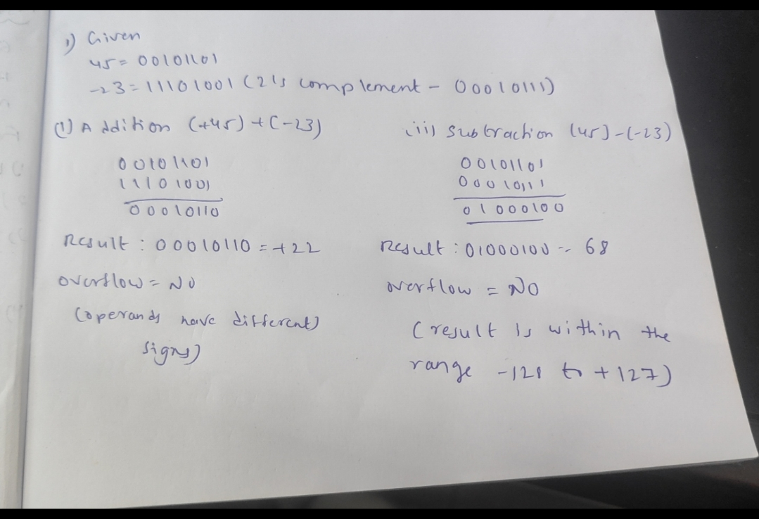
Q2. Carry Look-Ahead Adder

Carry Look-Ahead Adder
Example: A=1011, B=1101, C0=0
P=A⊕B = 0110
G=A·B =1001
C1=G0+P0C0
C2=G1+P1G0+P1P0C0
C3=G2+P2G1+P2P1G0+P2P1P0C0
C4=G3+P3G2+P3P2G1+P3P2P1G0+P3P2P1P0C0

Term | Formula | Purpose
Propagate | P=A⊕B | Propagates carry
Generate | G=A·B | Generates carry
C1 | G0+P0C0 | Carry 1
C2 | G1+P1G0+P1P0C0 | Carry 2
Explanation:
• CLA calculates all carry bits simultaneously.
• Ripple Carry Adder waits for each carry sequentially.
• Hence CLA has much lower propagation delay and is used in high-speed processors.

Q3. Booth Multiplication

Booth's Multiplication
Multiply -6 × +5
M=-6=11111010
Q=00000101
A=00000000 Q-1=0
Apply Booth rules for 8 cycles:
01 -> A=A+M
10 -> A=A-M
00/11 -> No operation
Arithmetic right shift after each cycle.
Final Product = 11100010 = -30

Cycle | Q0Q-1 | Operation | Shift | Remark
1 | 10 | A=A-M | ARS | Subtract
2 | 01 | A=A+M | ARS | Add
3-8 | 00/11 | No Operation | ARS | Continue
Explanation:
• Booth's algorithm efficiently multiplies signed numbers.
• It reduces unnecessary additions for consecutive 1's, improving speed.

Q4. Restoring and Non-Restoring Division

Restoring Division Example: 13/3
Dividend=1101
Divisor=0011
Shift left, subtract divisor.
If result negative, restore remainder and set quotient bit=0.
Else quotient bit=1.
Final Quotient=0100 (4)
Remainder=0001 (1)
Explanation:
• Restoring division restores the previous remainder whenever subtraction becomes negative.
• Non-restoring division skips this restoration during each iteration, making it faster and requiring fewer operations.

Q5. IEEE-754 Floating Point

IEEE-754 Representation of -13.25
13.25 = 1101.01₂
Normalized =1.10101×2^3
Single Precision:
Sign=1
Exponent=3+127=130=10000010
Mantissa=10101000000000000000000
32-bit:
1 10000010 10101000000000000000000
Double Precision:
Exponent=3+1023=1026=10000000010
Mantissa=1010100000000000000000000000000000000000000000000000

Field | Single Precision | Meaning
Sign | 1 | Negative
Exponent | 10000010 | Bias 127
Mantissa | 10101000000000000000000 | Fraction
Explanation:
• IEEE-754 stores a floating-point number using three fields: Sign, Exponent, and Mantissa.
• The exponent is stored using a bias (127 for single precision, 1023 for double precision).
• Normalization improves precision and ensures a unique representation.

